1. WorkFlow Of Offline Application

- User logs in (on top right Site code (5 character) and App version should be displayed and should be set from Backend by admin)

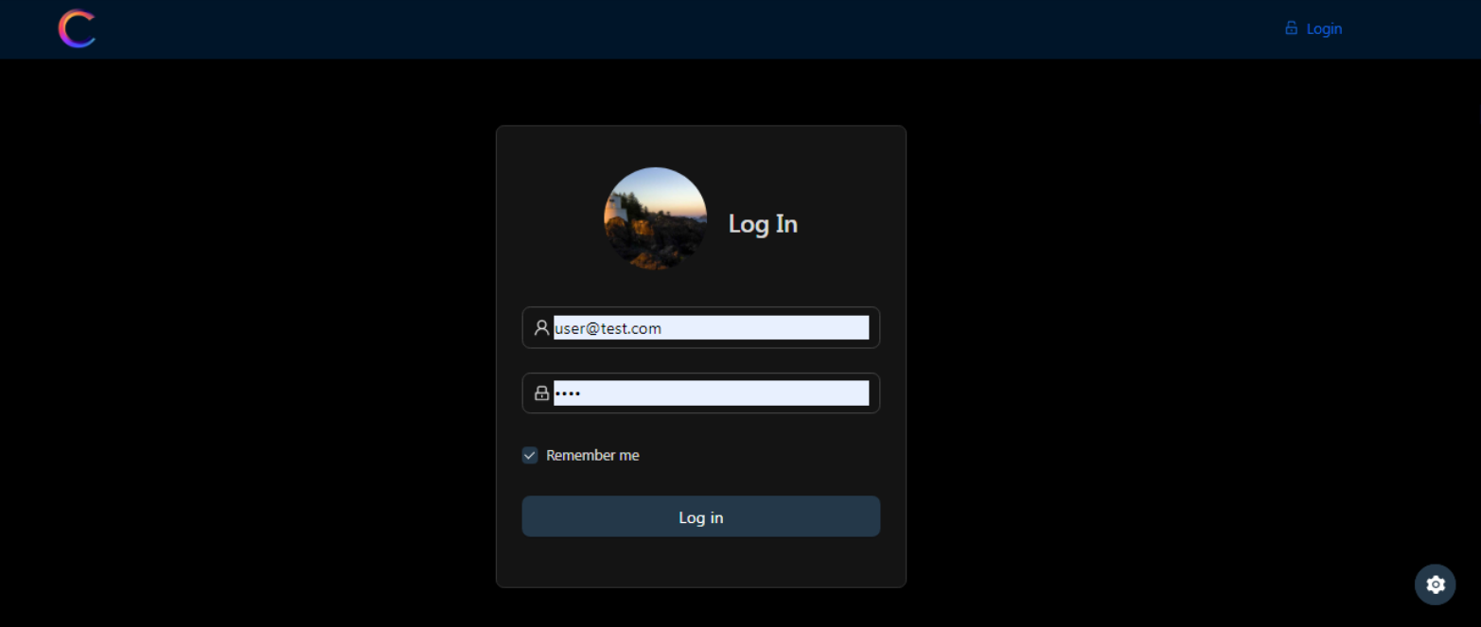 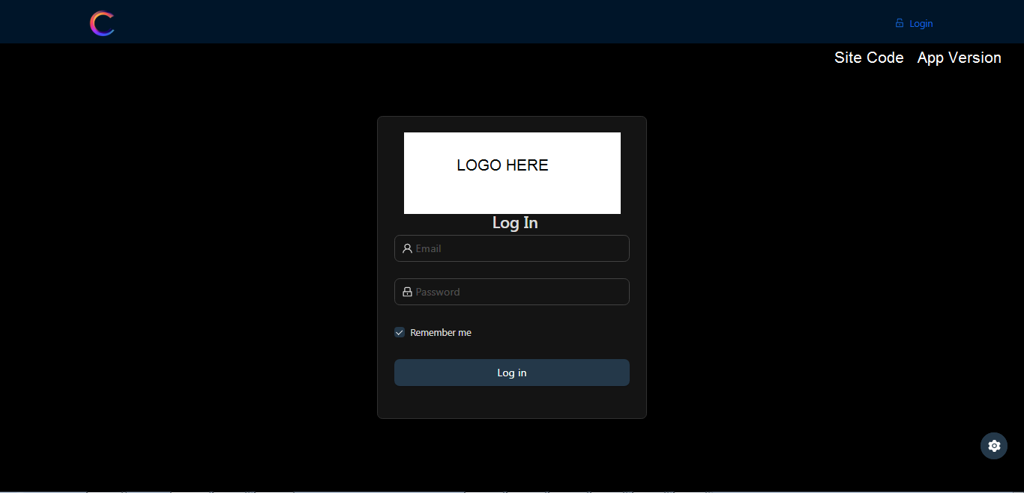

- After log in, redirect to dashboard.

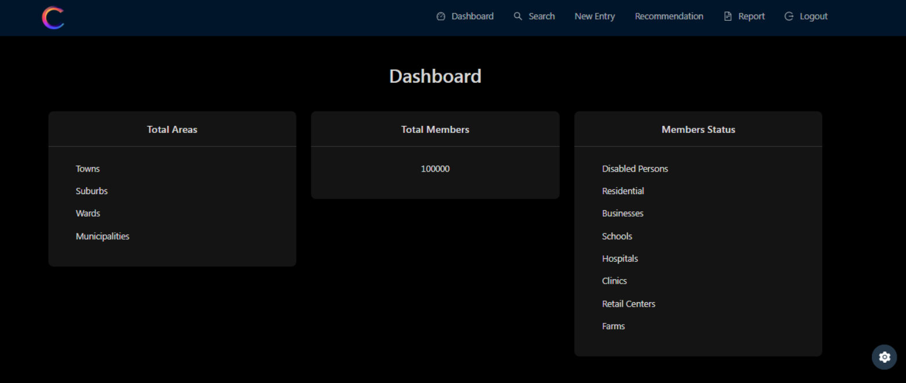

Here in dashboard All data saved in database will be displayed with their terms.

And barchart or pi chart will be added there.

This dashboard page will be customized in the last of the second milestone because we need to work with Entry and Recommendation pages to save data. Once they are completed then we will add all necessary forms there.

- New Entry (Personal & Business)

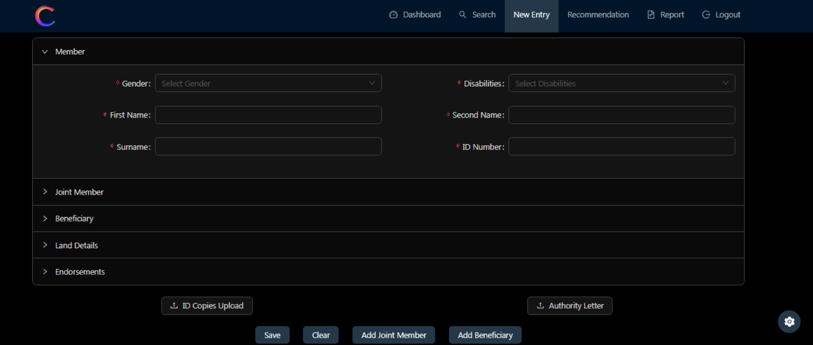

User can add the personal entry which has member’s data, here joint member, beneficiary, land details and endorsement are optional.

Joint member and Beneficiary should have option to add additional joint member and additional beneficiary.

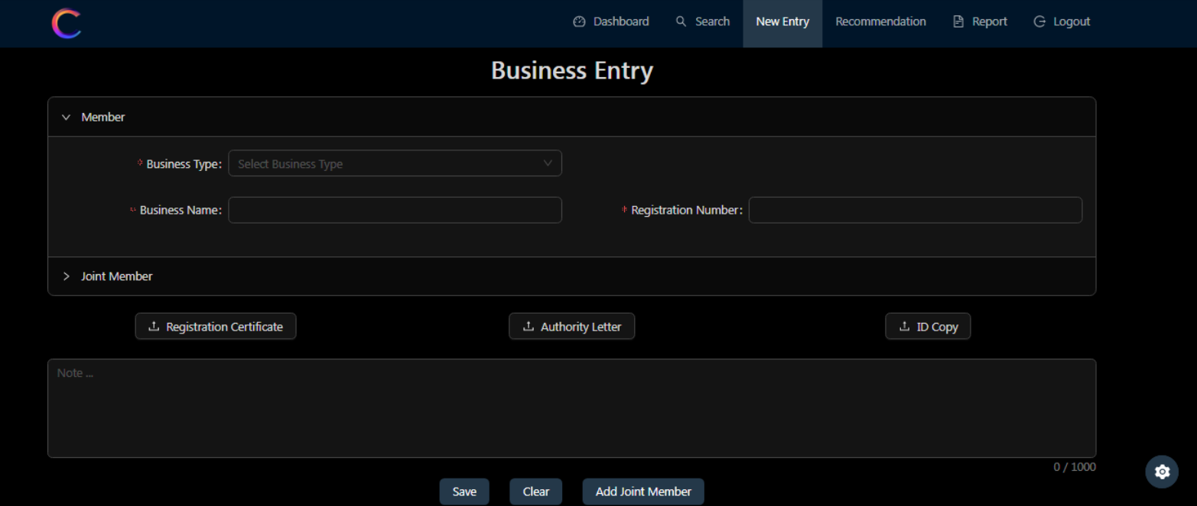

Current Business Entry is on draft of customizing. But similar option with the Personal Entry. **Noted**

Business form should only have Member, Joint member, Land details and Endorsement (Beneficiary does not apply)

Joint member should have option to add additional Joint member.

Land Details to revised to have same fields as on Personal form .

**LAND DETAILS**

Land fields on both Personal and Business should have the names rearranged and renamed as follows

Stand number , Land Use,

Street Address,Suburb ,

Town,Region,

Province,Ward Number,

Latitude,Longitude with default comma in the middle to separate the codes , Municipal ,

Area Size and Estimated Valuation.

Add 1 extra field Named “Occupation Date”

The Workflow process

User capture data in all forms in New Entry and save the data as one form or document to be printed as certificate , Once data is saved it automatically auto generate Reference number (Account number) that get saved with Date stamp and user details who created it. Once data is saved the stand number gets populated in the Finance Form awaiting to be updated with payment receipt details and to be approved. Once is approved in the Finance form ,the New Entry gets flagged with PAID status displayed on the top right which then enables the document to be printed with the unique security label code on the round label area (to be seen on the sample) on the document which can be printed as pdf or as a hard copy.

The data from saved New Entry data is then populated in the report database ready to be used to generate the report. The same data is also used in the Recommendations Personal/Business form to populate the form once ID number of the member or Business registration number is entered in the designated field to pull the data to populate the Recommendation form. User do not have to capture any data in Personal/Business recommendations forms except in the General form User only enter ID number or Registration number.The member cannot be provided with recommendation if member’s data is not already captured in the New Entry whether as member or Joint member or Beneficiairy or a busniess.

The App should not allow recapturing of the same stand number.

- Recommedation

We have three recommendation pages, and key value is print option which renders pdf format of the created recommendation.

Here we will add company logo (All forms to have logo and business details only when printed) and (not to have - app version in the document.)

- Reports

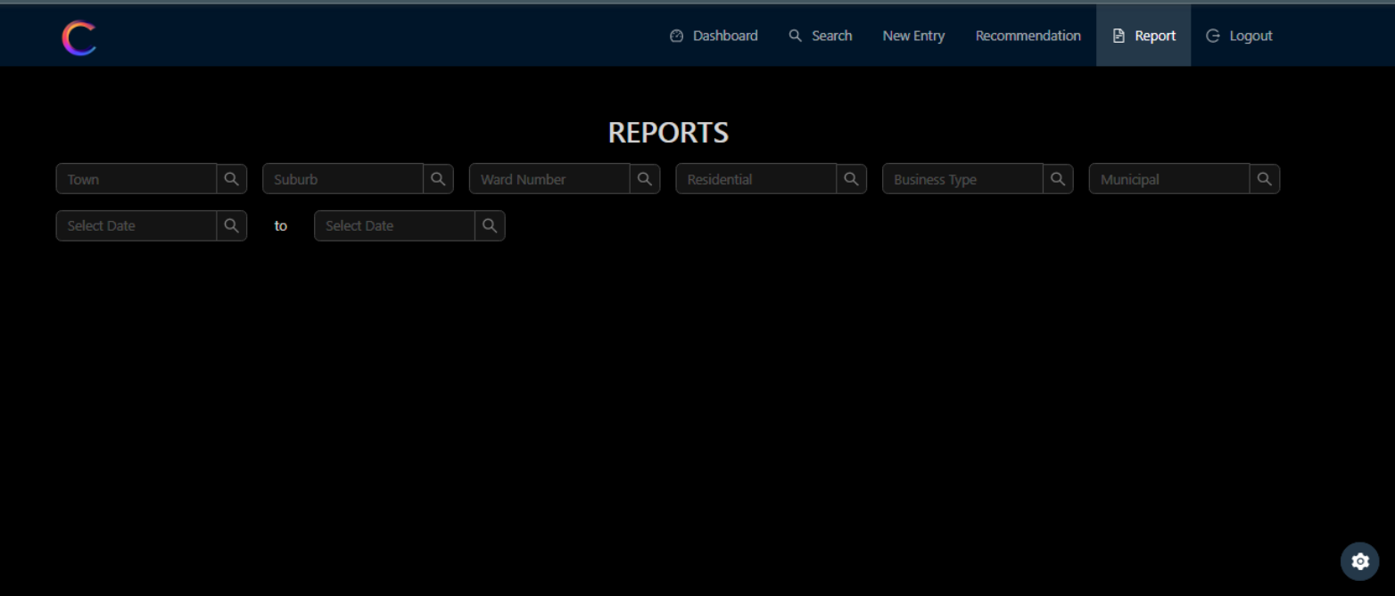

Current reports page is here and now we will add form of the report with search options.

- Now here goes the additional question and request:  
1) User should goes all Entry and Recommendation when he creates new member? ???

1. What is exactly optional when save data? Data captured in all forms should be saved with date stamp and be able to be searched with ID number and Business registration number and stand number linked to it.
2. Check the workflow above and if anything out of your mind, let me know. Listed at the bottom
3. Second Milestone Plan.

- Starting with Entry pages which leads the personal and business entry database design. Noted

So New entry pages aims to create member’s data so each member data will be saved as independently with User’s data who created the member. A completion of all for steps (i.e. Member/Joint member/Beneficiary/Land details/Endorsements) is considered one complete entry to be saved as one and it will be printed as one with one auto generated reference which should begin with Site code + any series may be to begin with stand number (To be later called Account Number) and with User’s data who created it. e.g Site code NZHE1 , Stand number is T011 , Series number 00001 the Auto generated ref or Account number will be NZHE1T01100001

Once db design finished, will conduct on Backend development Noted

This will take the whole week or more to finish I guess. Noted

- After finshing the Entry pages, I will complete Recommendation pages. As pdf generation will be key part in this step, and here I need sample pdf recommedation or it’s format that I can refer. Noted

Recommendation pages will also take one week to be finished.

I think It’s better to set the second milestone (600USD) with Entry and Recommendation pages, As these pages require 2 weeks or more time. And this is the key part of the application so let’s start with this plan. ? I don’t understand , you mean to first pay ?

Once second milestone completed, let’s finish dashboard and search pages with Report too.?

Recommendations Forms

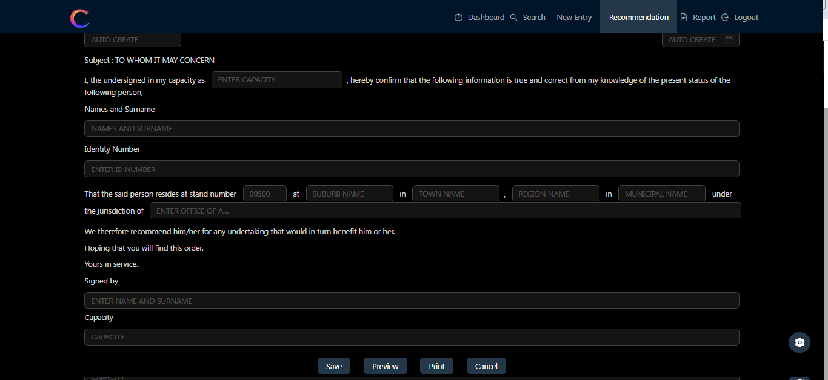

Extend the field bar after the sentence ending with..the jurisdiction of…….to make it longer until to the end on both Personal and Business forms (see on above sample).

Correct Text – Add **in** on “Hoping that you will find this **in** order.” On both Personal and Bsiness forms.

**Buttons on All Forms**

All forms should have buttons for options to SAVE , EXIT/CANCEL,PREVIEW and to PRINT in different screen mode

**Data capture screen** - User should have options to **Save** , **Exit** and **Print**

**Search to view data screen** - User should have options to **Preview** and **Print** captured data.

**Printing Feature on New Forms**

User should only be able to print saved data in New Entry forms once “**PAID” stamp** is activated after saving the data and PAID stamp is displayed on the captured form .Refer to Financial Form Features.

The App should be able to print all forms as hard copy and as pdf to be saved in a folder.

**Document upload Feature**

Uploaded documents should have date stamp to display date and time they were uploaded

**Recommendations Forms data capture**

User should be able to populated data in the forms by entering member’s ID number for Personal forms and Business registration number for Business forms of members already captured in the app.

FINANCE FORM

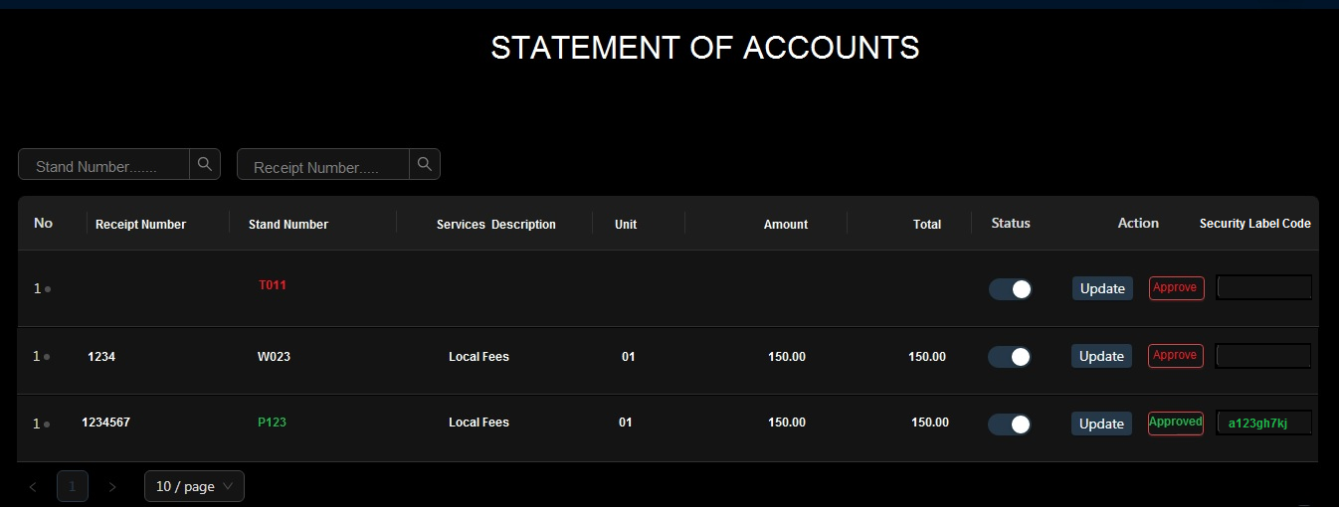

This is an additional form to be added in the Front End after Reports

Its workflow begins when a User capture data in New Entry form (Personal/Business) and once the form is completed and saved ,it activates the auto generated reference number to be created , the stand number gets sent to the Finance form and is populated here waiting for User to update it with payment receipt details and Approves it. Once Approved button is selected it auto generate security label code and it gets displayed and it activates PAID status on the top right of the saved New Entry data form and it then enables the form document to be printed. User will go to search and use the stand number or Business Registration number or ID numbers of one of the members captured in the form to pull the saved data and will see the saved data with PAID status on the top right .Without the PAID status the New Entry form data cannot be or should not allow printing of the document and or the print button would not display to allow printing. Only user with finance permission is able to use features of the finance form and is the only one who can view the security label code on it.

ADD permission level 4 – and Finance (User) – With permission to add/update the finance form.

The following should only be entered from Backend by the administrator

Site code – to be use for display in the front end login screen , to be used as prefix code for auto generated reference number in the forms and on the printed documents

App version – to be displayed on the frontend login screen

Business Logo for the forms – to display on all printed document as letter head

Business address and contact details for the forms - to display on all printed document as letter head

**Document Samples to Follow**